Workplace Bias & Career Progression in UK Education Leadership

A Statistical Analysis Using ANOVA

Prepared by: Anetoh Olivia Chinecherem

Role: Data Analyst

Date: April 2026

Table of Contents
Introduction 2
Methodology 3
Findings 6
Conclusion 11
Recommendations 12

Introduction
This report presents a statistical analysis of workplace bias and career progression among education leaders in the United Kingdom. The study is based on survey data collected from 35 superintendents, examining how personal demographics such as gender, age, and years of experience influence their perception of workplace bias and career advancement.
The analysis was conducted using the Analysis of Variance (ANOVA) method in Microsoft Excel, with a significance level of 0.05. Five hypotheses were tested to determine whether statistically significant differences exist across different demographic groups.
The findings of this report aim to provide evidence-based insights into the lived experiences of education leaders, with particular focus on gender inequality and bias in the workplace.

Research Questions & Hypotheses
This study sought to investigate the impact of workplace bias on career progression among education leaders in the United Kingdom. Five research questions were formulated to guide the analysis:
- Is there a statistically significant difference in perceived workplace bias across gender groups in education leadership?
- Is there a statistically significant difference in perceived workplace bias across age groups in education leadership?
- Is there a statistically significant difference in career progression outcomes based on years of professional experience?
- Is there a statistically significant difference in career progression outcomes based on gender?
- Are there statistically significant differences in the perception of professional environment across demographic groups?
For each research question, a null hypothesis (H₀) and alternative hypothesis (H₁) were established and tested using ANOVA at a significance level of 0.05.

Methodology
Data Source
The data used for this analysis came from a structured questionnaire completed by 35 education leaders in the United Kingdom. The questionnaire covered four areas demographics, workplace bias, career progression, and professional environment.
Step 1: Data Coding
Because Excel cannot perform calculations on text, all text responses were converted to numbers. Below is exactly how each column was coded:
Gender
Female = 1
Male = 2
Age Group
35–39 = 1
40–44 = 2
45–49 = 3
50–54 = 4
55–60 = 5
60+ = 6
Administrative Experience (Roles Held)
1–2 roles = 1
3–5 roles = 2
6–7 roles = 3
8+ roles = 4
Bias Questions (How concerned were you...)
Not at all concerned = 1
Slightly concerned = 2
Moderately concerned = 3
Somewhat concerned = 4
Very concerned = 5
Career Behaviour Questions (Have you ever intentionally...)
No = 0
Does not apply to me = 0
Sometimes = 1
Yes = 1
Professional Environment Questions (How important were the following...)
Not important = 1
Slightly important = 2
Somewhat important = 3
Moderately important = 4
Very important = 5
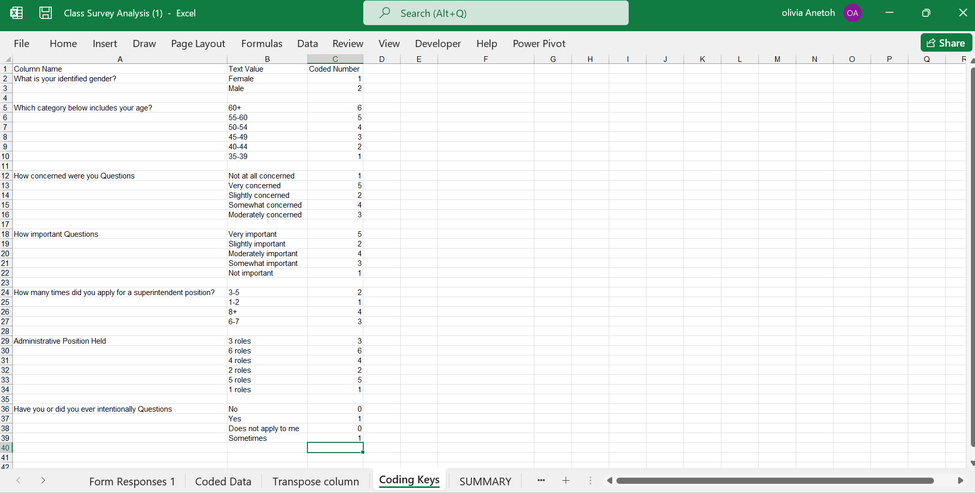
Figure 1: Coding Key Reference Sheet showing all coded variables and their assigned values.

Step 2: Creating Composite Scores
After coding, three composite scores were created by adding up related columns for each respondent:
PB (Perceived Bias): Total score from all "How concerned were you" questions
PPE (Perceived Professional Environment): Total score from all "How important were the following" questions
CP (Career Progression): Total score from all "Have you ever intentionally" questions
Step 3: Running the ANOVA
ANOVA Single Factor was run five times in Microsoft Excel using the Data Analysis ToolPak — once for each hypothesis. A significance level of 0.05 was used for all tests. Results were interpreted using three values F value, F critical value, and p value.

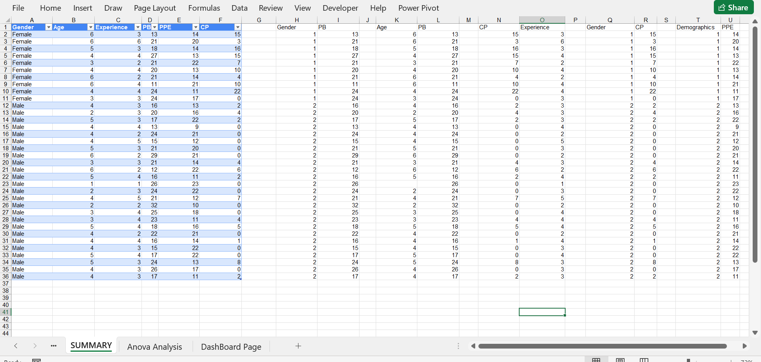
Figure 2: Summary sheet showing the final cleaned and coded dataset used for analysis.

Findings
H1: Is there a significant difference in perceived workplace bias across gender groups?
ANOVA Results:
F value = 482.69
F critical = 3.98
P value = 1.34E-32
Since the F value (482.69) is greater than the F critical (3.98) and the p value (1.34E-32) is less than 0.05, the null hypothesis was rejected.
There is a statistically significant difference in perceived workplace bias across gender groups. Males reported a slightly higher average bias score (20.4) compared to females (20.0). This confirms that gender influences how workplace bias is perceived in UK education leadership.
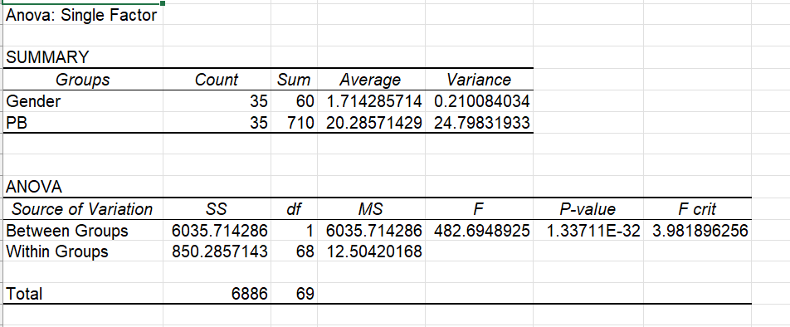
Figure 3: ANOVA Single Factor result for H1 - Perceived Bias across Gender Groups.

H2: Is there a significant difference in perceived workplace bias across age groups?
ANOVA Results:
F value = 334.75
F critical = 3.98
P value = 9.26E-28
Since the F value (334.75) is greater than the F critical (3.98) and the p value (9.26E-28) is less than 0.05, the null hypothesis was rejected.
There is a statistically significant difference in perceived workplace bias across age groups. Younger leaders aged 35-39 reported the highest bias score of 26.00, with scores declining steadily with age. This suggests that younger education leaders feel the impact of workplace bias more strongly than older ones.
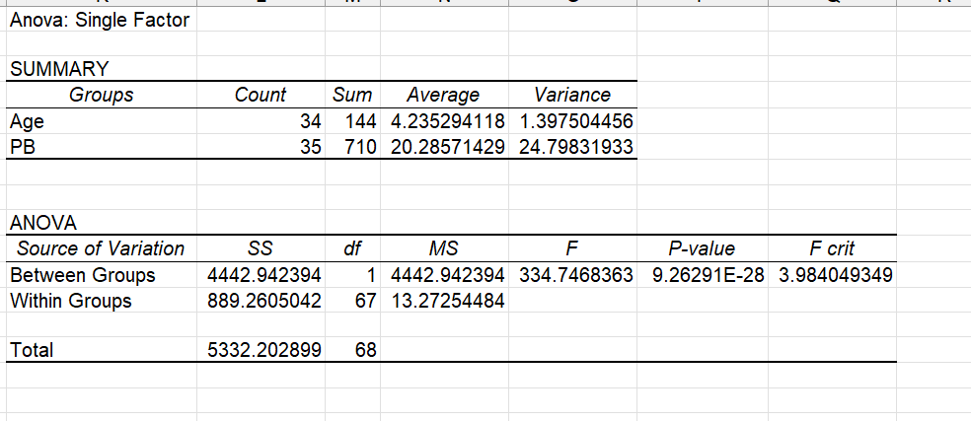
Figure 4: ANOVA Single Factor result for H2 - Perceived Bias across Age Groups.

H3: Does experience significantly influence career progression?
ANOVA Results:
F value = 1.08
F critical = 3.98
P value = 0.303
Since the F value (1.08) is less than the F critical (3.98) and the p value (0.303) is greater than 0.05, the null hypothesis was not rejected.
There is no statistically significant difference in career progression based on experience. Holding more administrative roles does not guarantee better career progression. This is the only hypothesis where no significant difference was found.

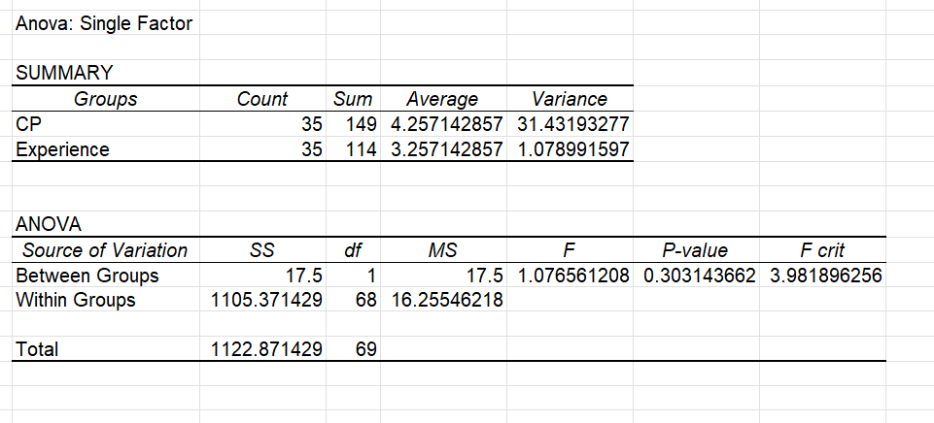
Figure 5: ANOVA Single Factor result for H3 - Career Progression based on Experience.

H4: Does gender significantly influence career progression?
ANOVA Results:
F value = 7.15
F critical = 3.98
P value = 0.009
Since the F value (7.15) is greater than the F critical (3.98) and the p value (0.009) is less than 0.05, the null hypothesis was rejected.
There is a statistically significant difference in career progression based on gender. Female education leaders recorded an average career progression score of 10.2 compared to 1.88 for males. This shows that females are modifying their behaviour significantly more than males just to advance in their careers.

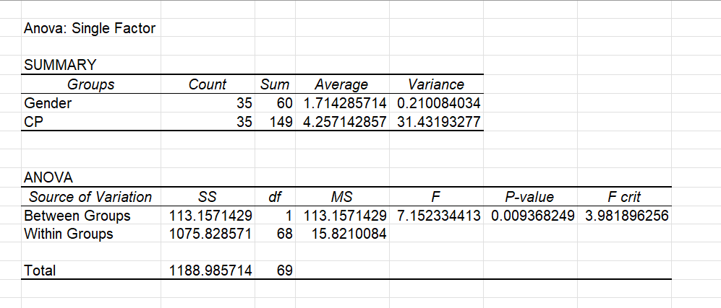
Figure 6: ANOVA Single Factor result for H4 - Career Progression based on Gender.

H5: Is there a significant difference in professional environment perception across demographic groups?
ANOVA Results:
F value = 375.03
F critical = 3.98
P value = 2.22E-29
Since the F value (375.03) is greater than the F critical (3.98) and the p value (2.22E-29) is less than 0.05, the null hypothesis was rejected.
There is a statistically significant difference in professional environment perception across demographic groups. Male education leaders rated their professional environment higher (16.52) compared to females (15.9), suggesting that males experience a more favourable working environment.

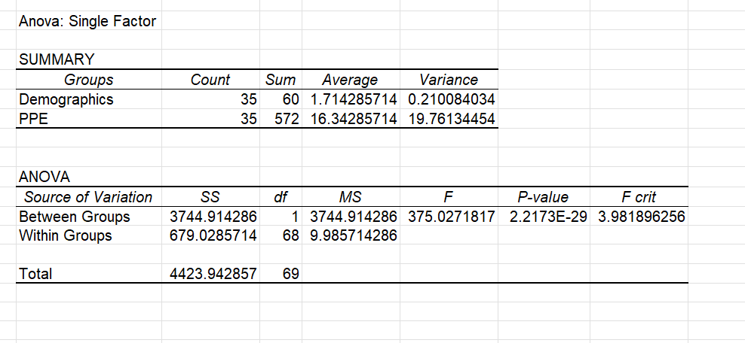
Figure 7: ANOVA Single Factor result for H5 - Professional Environment Perception across Demographic Groups.

Conclusion
This study looked at how workplace bias affects career progression among 35 education leaders in the United Kingdom. Five hypotheses were tested using ANOVA at a significance level of 0.05. Four out of five tests came back with significant results.
The findings are clear. Workplace bias exists in UK education leadership and it does not affect everyone the same way. Gender and age are the two biggest factors that influence how bias is felt and how careers grow.
Younger leaders feel the most bias at work. As leaders get older and more senior, the bias they feel reduces. This means bias hits hardest at the beginning of a career, which is exactly when it causes the most damage.
Gender tells an even stronger story. Female education leaders are changing their behaviour almost five times more than male leaders just to move forward in their careers. They are adjusting how they look, how they speak, and how they act, not because they want to, but because the workplace is pushing them to. Male leaders do not face the same pressure.
The workplace itself is not experienced equally. Male leaders rate their work environment more favourably than female leaders. This confirms that the same workplace feels like a very different place depending on your gender.
The only area where no significant difference was found was experience. Having more roles does not guarantee a better career. This challenges the common belief that experience is the key to progression. The data shows that gender is actually the stronger factor.
In summary, gender inequality in UK education leadership is real, present and measurable. It is not a feeling or an opinion. It is backed by data and statistical evidence.

Recommendations
Based on the findings of this study, the following recommendations are made to education institutions and policymakers in the United Kingdom:
1. Take Gender Bias Seriously
The data shows that gender affects both how bias is felt and how careers progress. Education institutions should put clear anti-bias policies in place. Staff involved in hiring and promotion decisions should go through regular unconscious bias training so that decisions are made fairly and not influenced by gender.
2. Support Younger Education Leaders
Younger leaders aged 35-39 reported the highest levels of workplace bias. This means they need the most support. Institutions should introduce mentorship programmes specifically for younger professionals entering education leadership. Having a senior leader to guide them early in their career can make a significant difference.
3. Make Career Advancement Fair for Everyone
Female leaders are working five times harder than males just to progress. Institutions should review how promotion decisions are made and ensure the process is transparent and equal for everyone. Clear career pathways should be available to all leaders regardless of gender.
4. Improve the Workplace Experience for Female Leaders
Male leaders feel more comfortable at work than female leaders. Institutions should regularly check in with female staff to understand their workplace experience. Female leaders should have equal access to networks, opportunities, and support systems that help them grow and feel valued in their roles.

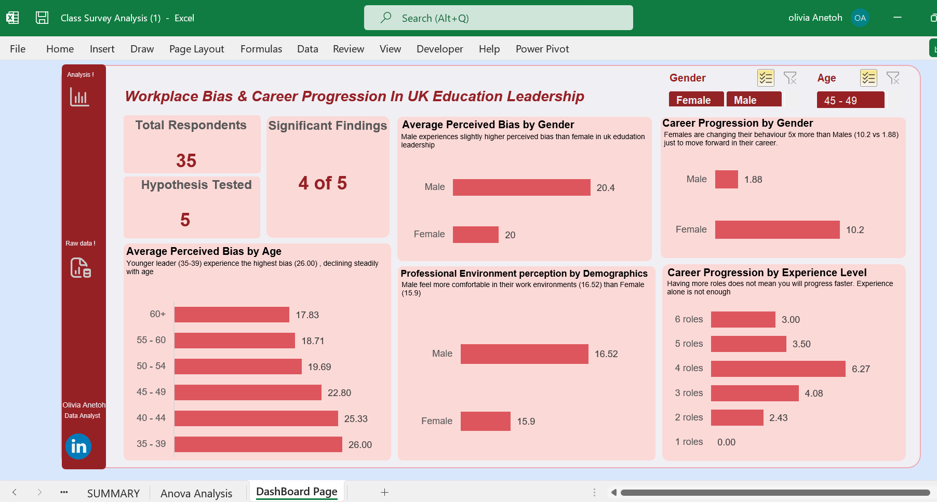
Figure 8: Interactive demographic dashboard showing key findings from the ANOVA analysis.

Figure 1: Coding Key Reference Sheet showing all coded variables and their assigned values.
Figure 2: Summary sheet showing the final cleaned and coded dataset used for analysis.
ANOVA Result Screenshots:
Figure 3: ANOVA Single Factor result for H1 - Perceived Bias across Gender Groups.
Figure 4: ANOVA Single Factor result for H2 - Perceived Bias across Age Groups.
Figure 5: ANOVA Single Factor result for H3 - Career Progression based on Experience.
Figure 6: ANOVA Single Factor result for H4 - Career Progression based on Gender.
Figure 7: ANOVA Single Factor result for H5 - Professional Environment Perception across Demographic Groups.
Dashboard Screenshot:
Figure 8: Interactive demographic dashboard showing key findings from the ANOVA analysis.
Table of Contents — should you have one?
Yes. Since this report has 7 sections plus figures, a table of contents makes it easy for the client to navigate.
In Word it is very easy to generate automatically:
Click where you want the table of contents
Click References tab
Click Table of Contents
Select the automatic style
Word will generate it instantly from your headings.

